CUSTOMER SUPPORT TICKET PRIORITY PREDICTION AND AUTOMATED ASSIGNMENT SYSTEM USING AGENTFORCE.

Milestone 1: Salesforce Account
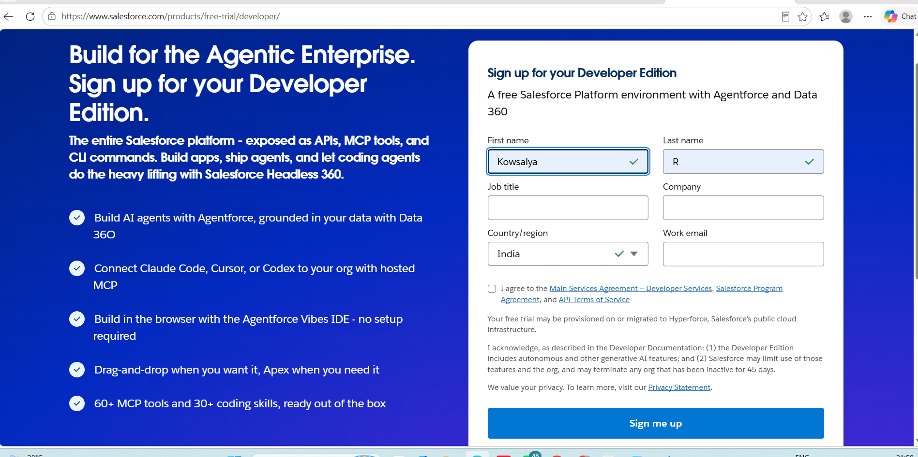
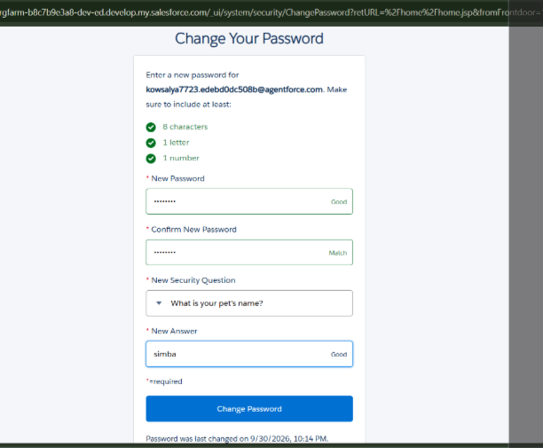
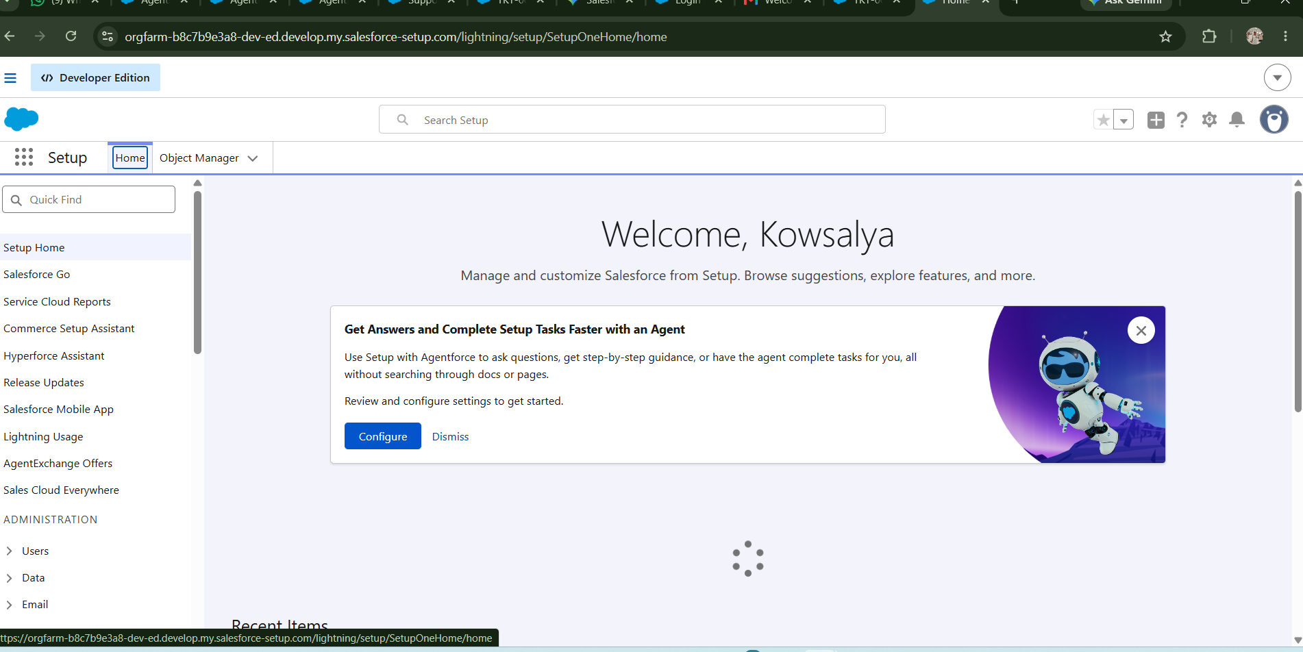
Milestone 2: Objects Creation
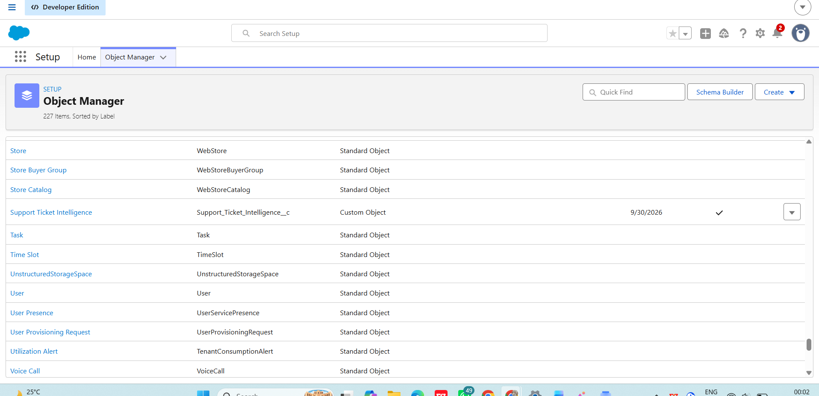
Custom Object Fields:
- Ticket Number (Auto Number: TKT-{0000})
- Customer (Lookup Account)
- Contact (Lookup Contact)
- Issue Type (Picklist: Technical, Billing, General)
- Description (Long Text Area)
- Priority Level (Picklist: Low, Medium, High)
- Status (Picklist: New, In Progress, Resolved)
- Assigned To (Lookup User)

Milestone 3:
Live Test Record Data (Replaced Data):
- Ticket Name: TKT-0001
- Customer (Account): kows
- Issue Type: Technical
- Description: urgent not working failure
- Priority Level: High
- Status: New
- Owner: Kowsalya R

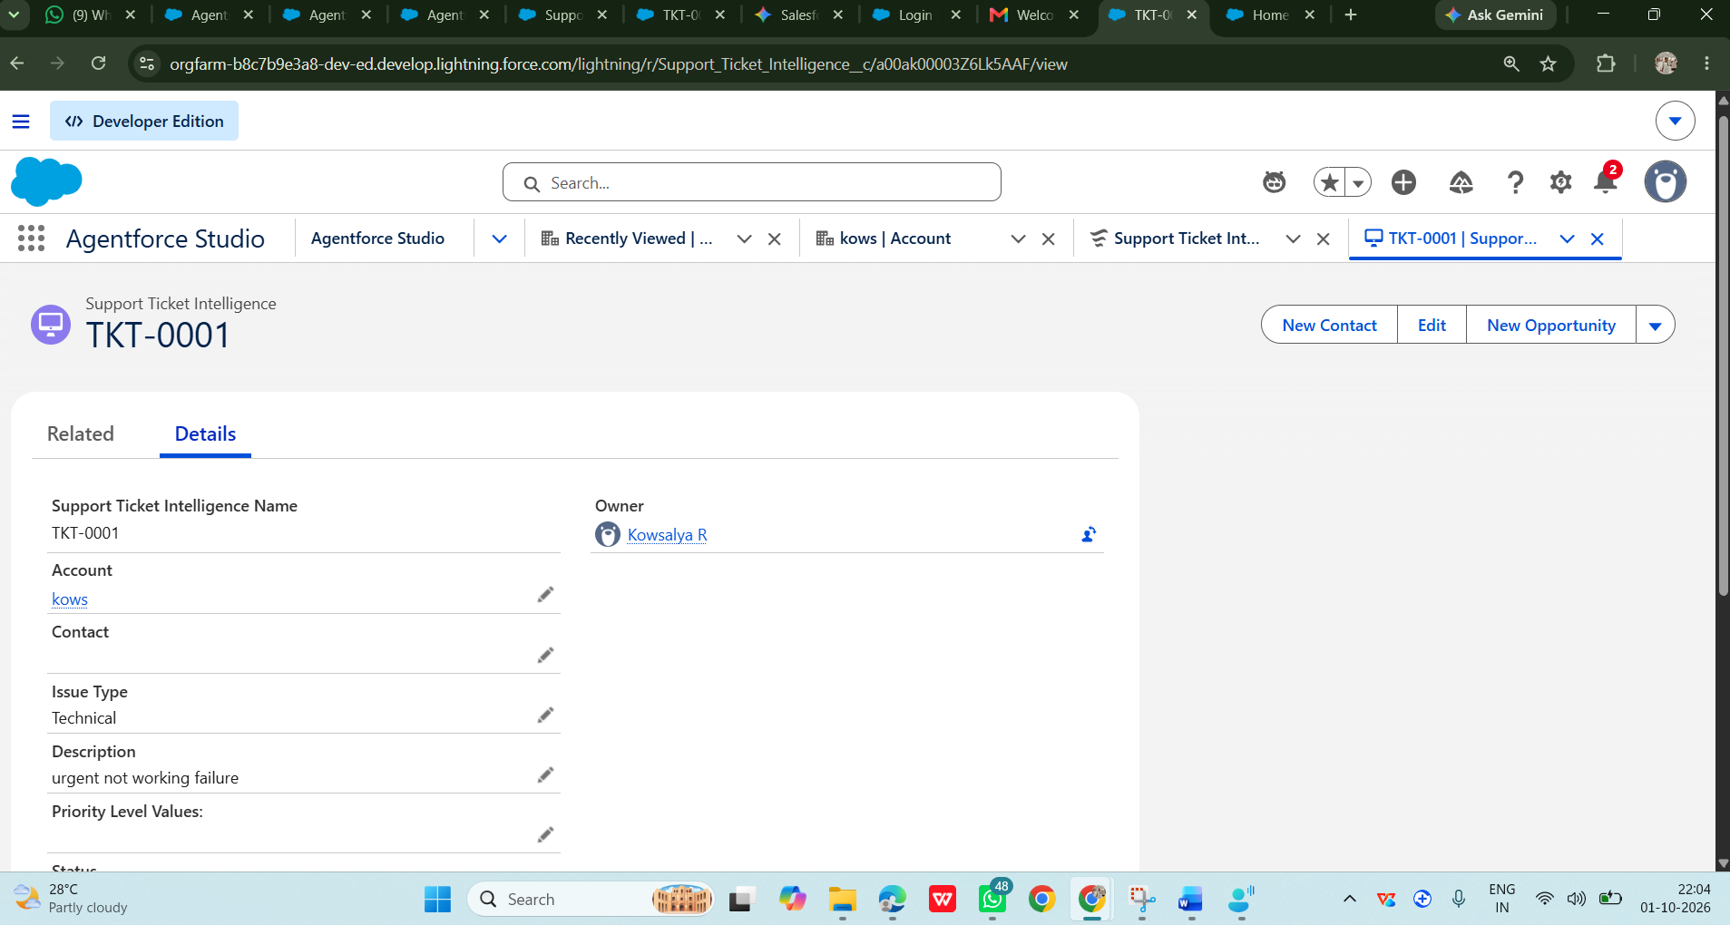
Milestone 4: Auto-Launched Flow Logic
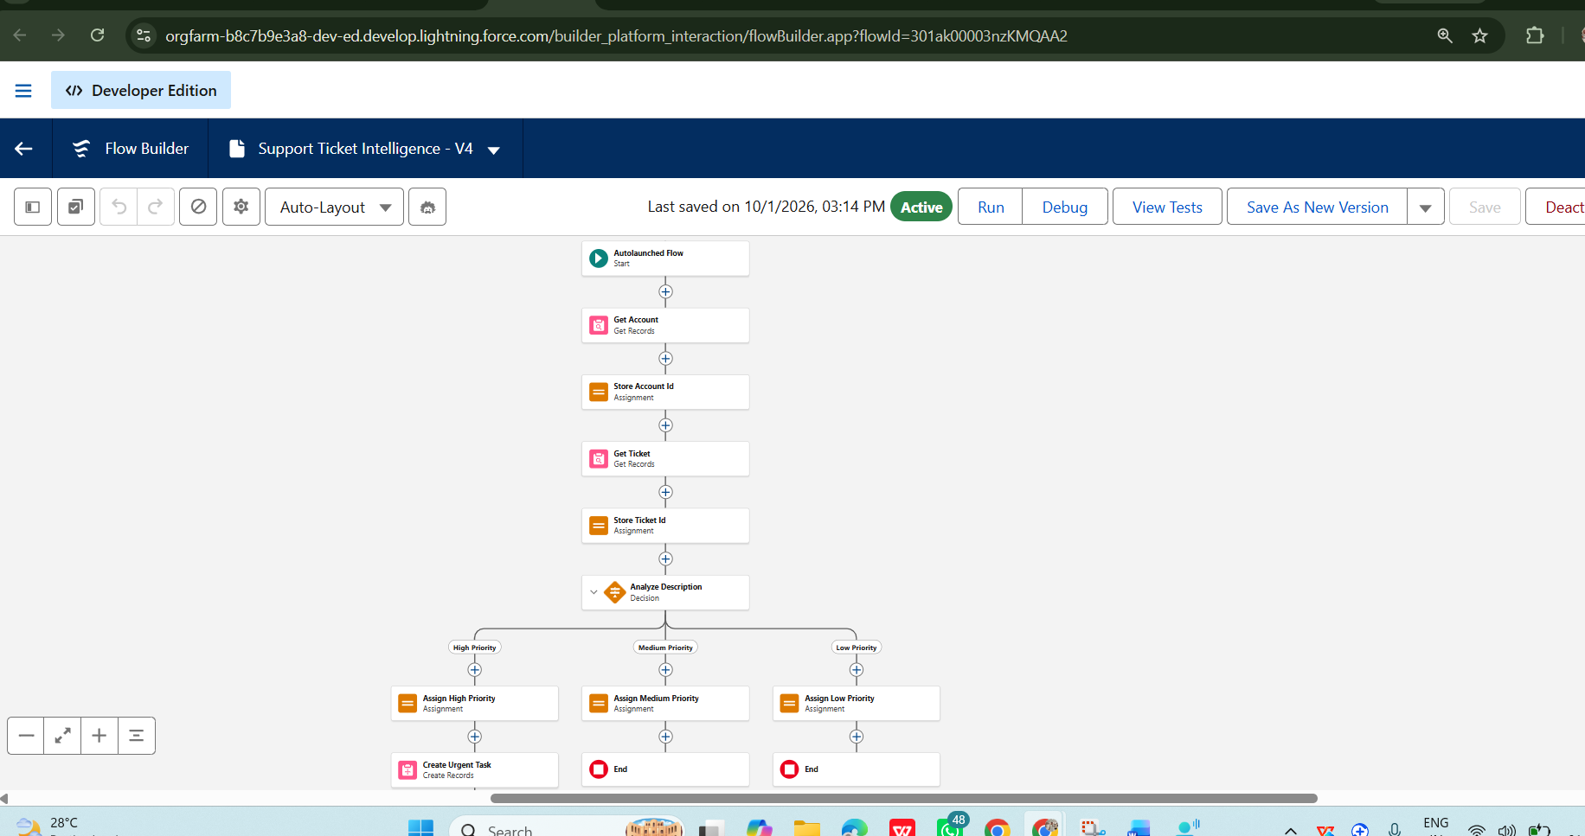
Agentforce Subagent & Action Mapping
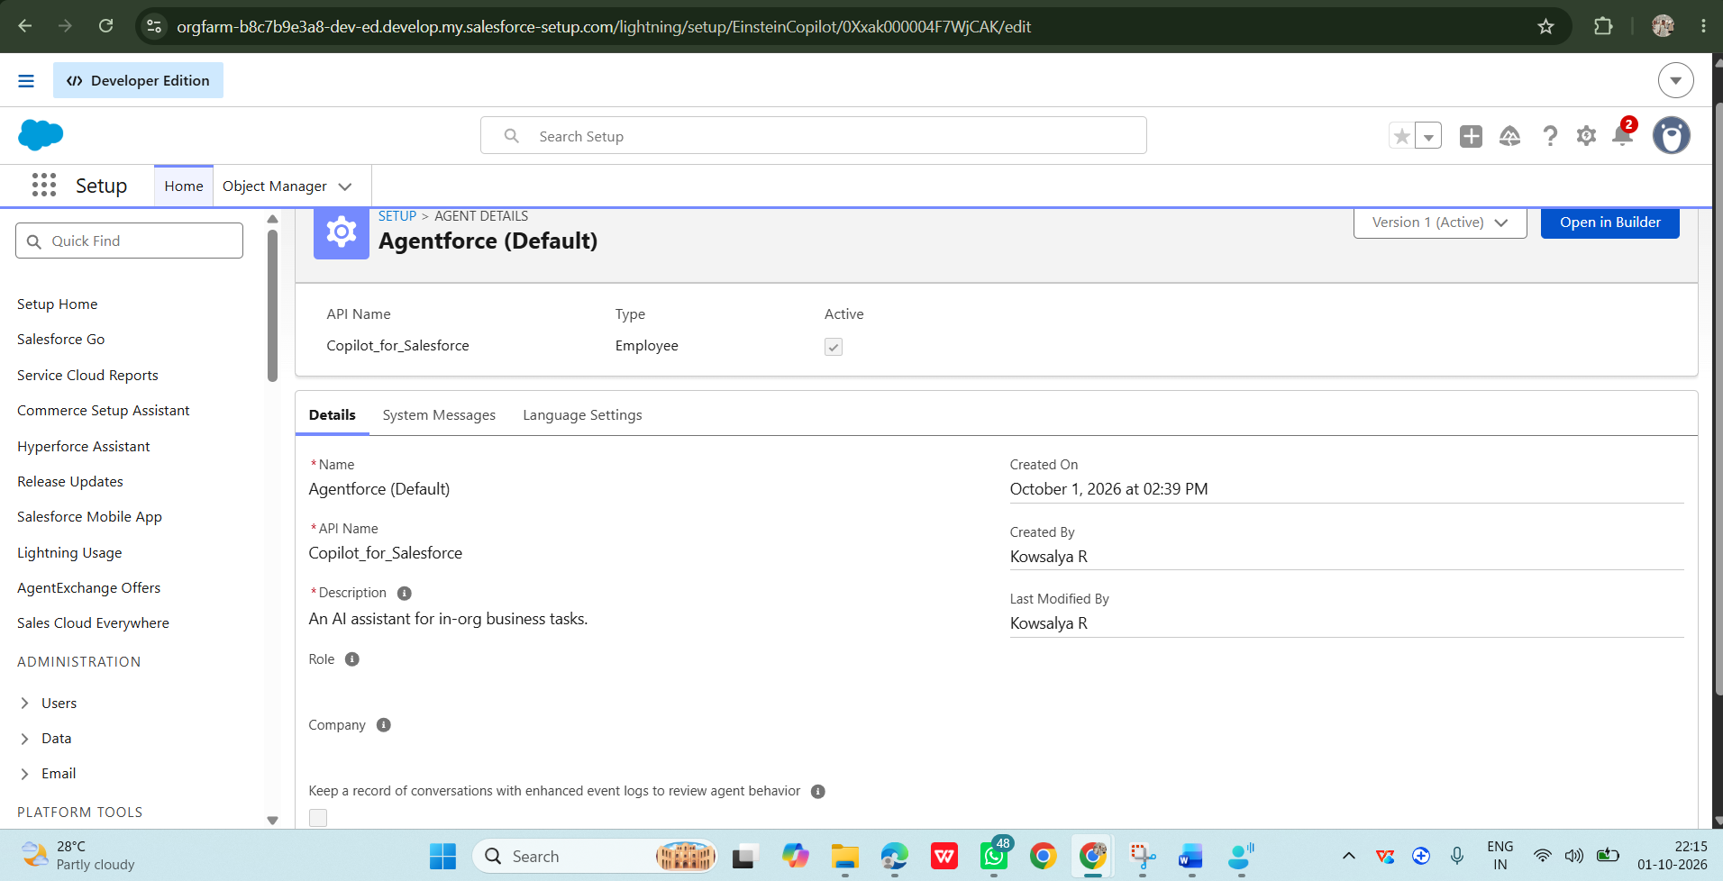
Final Execution & Live Output
